Using Google Maps, Google Earth, and Google Docs

Assignment 1:
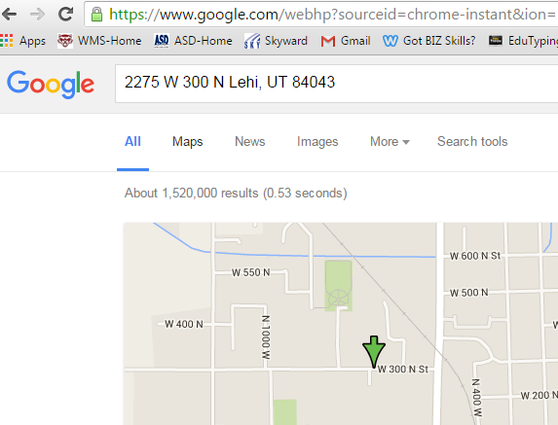
• Open Google Chrome web browser.

• Go to school Web page.
> Find mailing address of school.
> Copy address.

• Open new tab
> Paste school address in “search” bar.
> Press the Enter key

• Select Maps.
> Select “directions”.
> Type in student’s home address.
> Press the Enter key.

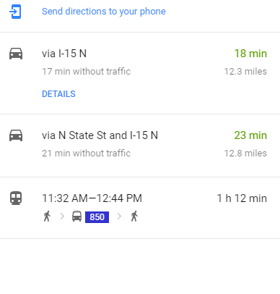• Take a screen shot or use print screen.

Assignment 2:

• Open Google Docs
• Title the page: Mapping My World
• Type in your Name and Period
• Paste the screen shot you took earlier.
• Answer these questions:
- How long/far does it take to bike to school?
- How long/far does it take to walk to school?
- Do you need to drive on the freeway to get to school?
- Do you need to fly on an airplane to get to school?
- Share your Google Doc with Ms. Revoir: mrevoir@alpinedistrict.org

