BIG DATA
College & Career Awareness

People often need to find out the opinions of others. A good way to do this is by creating a survey with questions that you want answered. Google has a feature called Forms that make this task easy.
- Open your email.
- Find the “Google Apps” button that looks like this and click on it:
- Look for the “Forms.” You may need to click on “More” at the bottom of the screen to find it.
- Select “Start a new form. . .Blank”
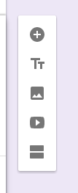
- Click on “Untitled form” and give your form a name.
- Click on “Form description” and give your form a description.
- Click on “Question” and type in your first question.
- Click on “Option 1” and type in your first answer choice.
- Click on “Add option” and type in your second answer choice.
- Continue until you have 4 answer choices.
- On the far right your will see some buttons. Use the plus sign to create more questions.
Check out the other buttons too.
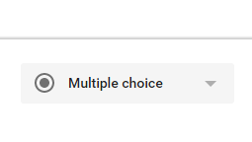
- You will also see this button:
The small triangle opens a screen that will let you change the type of question you are asking.
You have just created a multiple choice question, now try to create a different type of question.
- Create a minimum of 10 questions.
- When you are done, you will want to get several people to take your survey. At the top right is a button that looks like an eye. It is the preview button. Click on it to see what your customers will see.
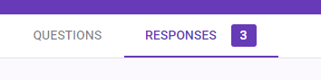
- Ask several people in class to take your survey and use the “Submit” button to submit their answers.
- When you are done, check the responses:

